**Assignment no 3**

**Software constructioin lab**

*Zia tariq(Fa16-bse-071)*

*Faisal aslam (Fa16-bse-085)*

*Hussnain ali (Fa16-bse-091)*

*Kashan malik (Fa16-bse-102)*

1. First we created a profile a profile in Github : 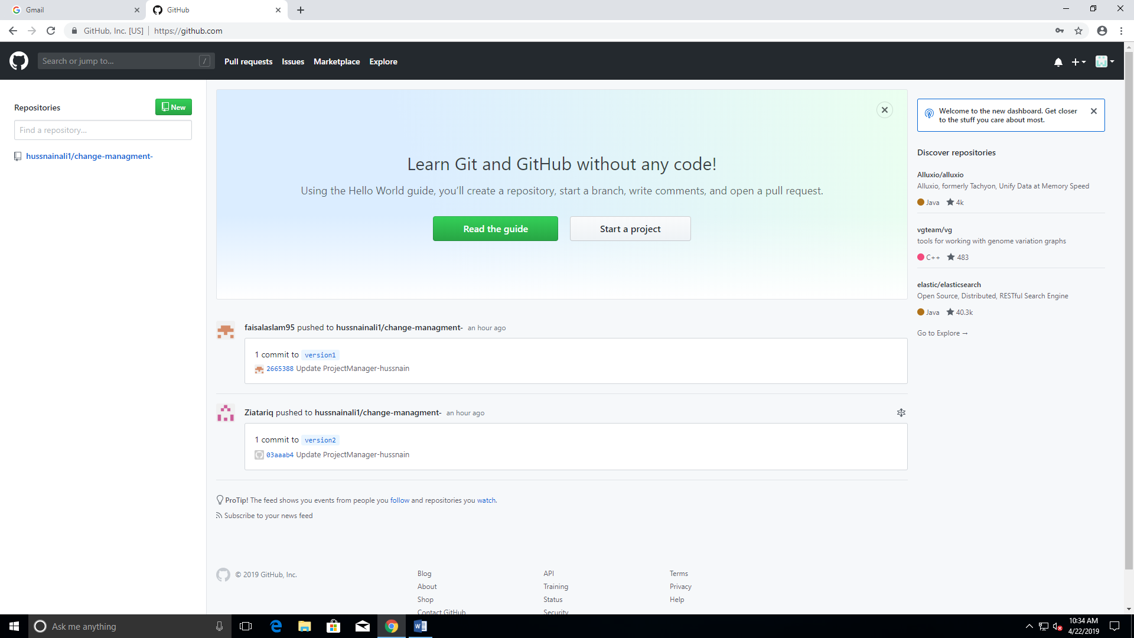
2. Then we created a repository in this profile : 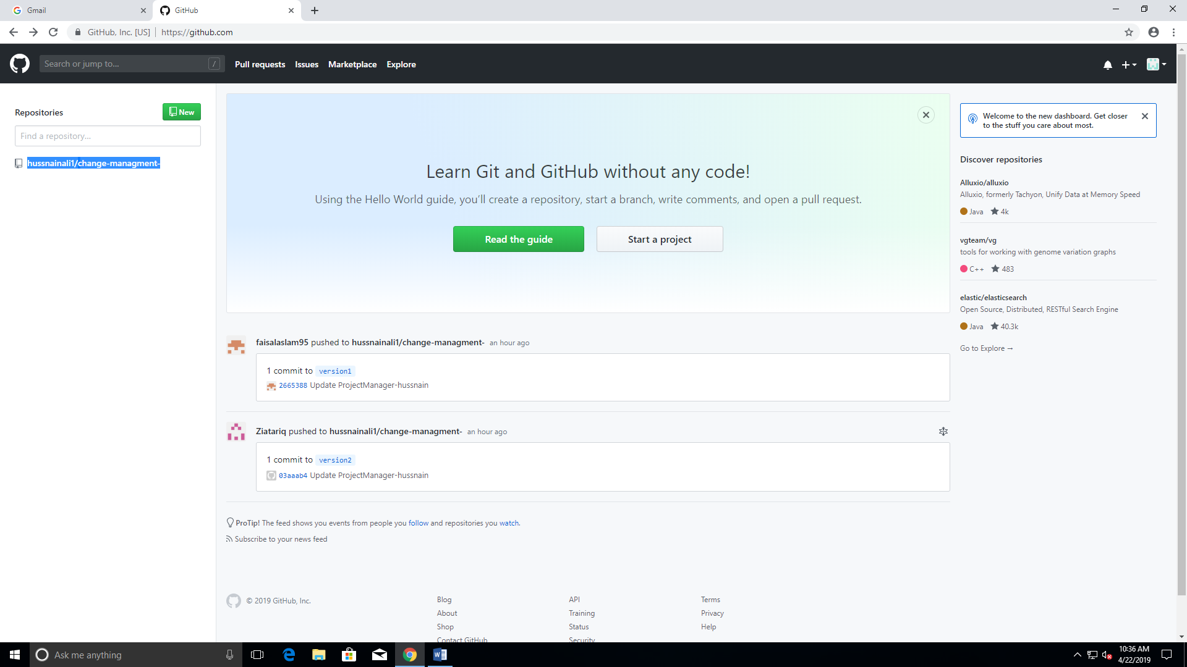
3. Then we add collaborator which are group members in this repository :

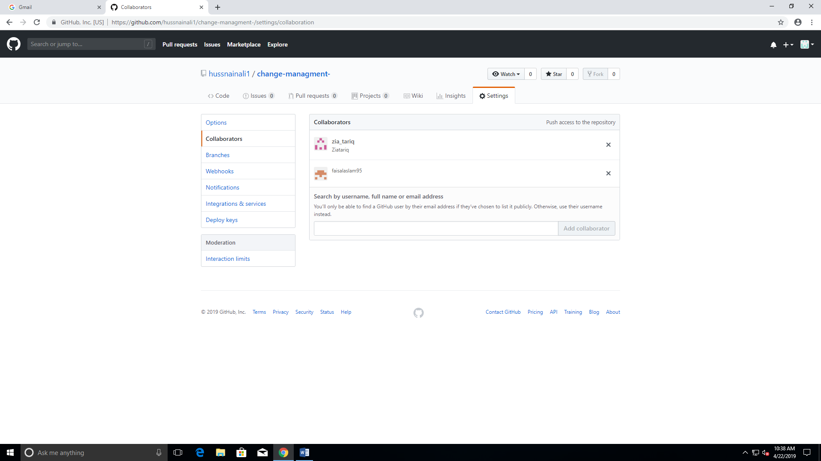

1. Then all collaborators created the branch to the master project:

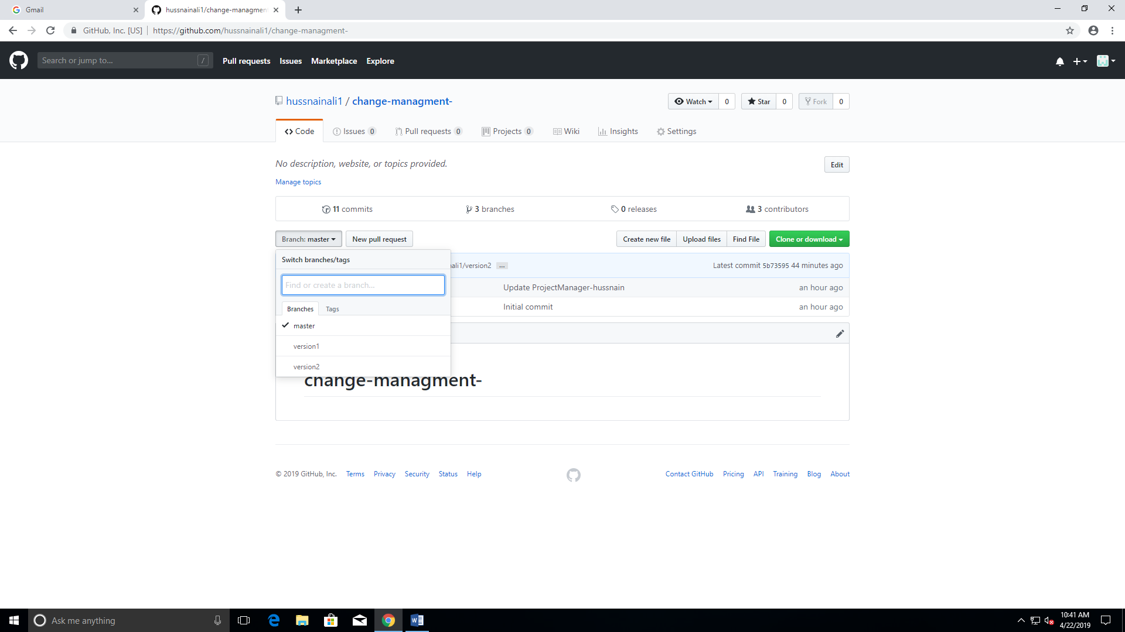

1. Both the member made changes and pull this changes :

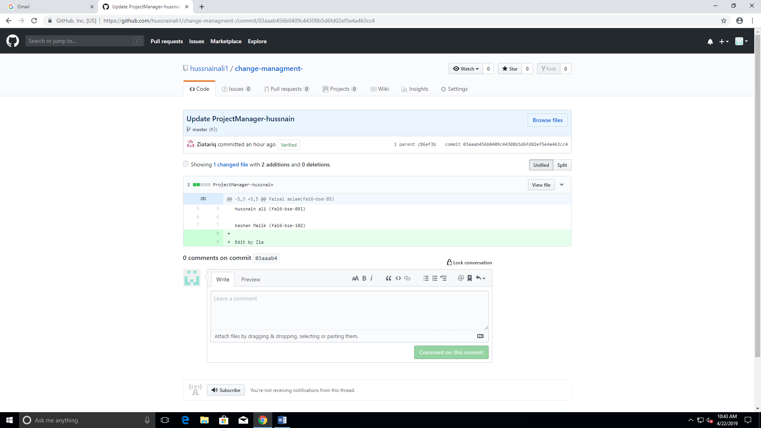

1. Then in project managers account check check pull request and merge all the pull requests:

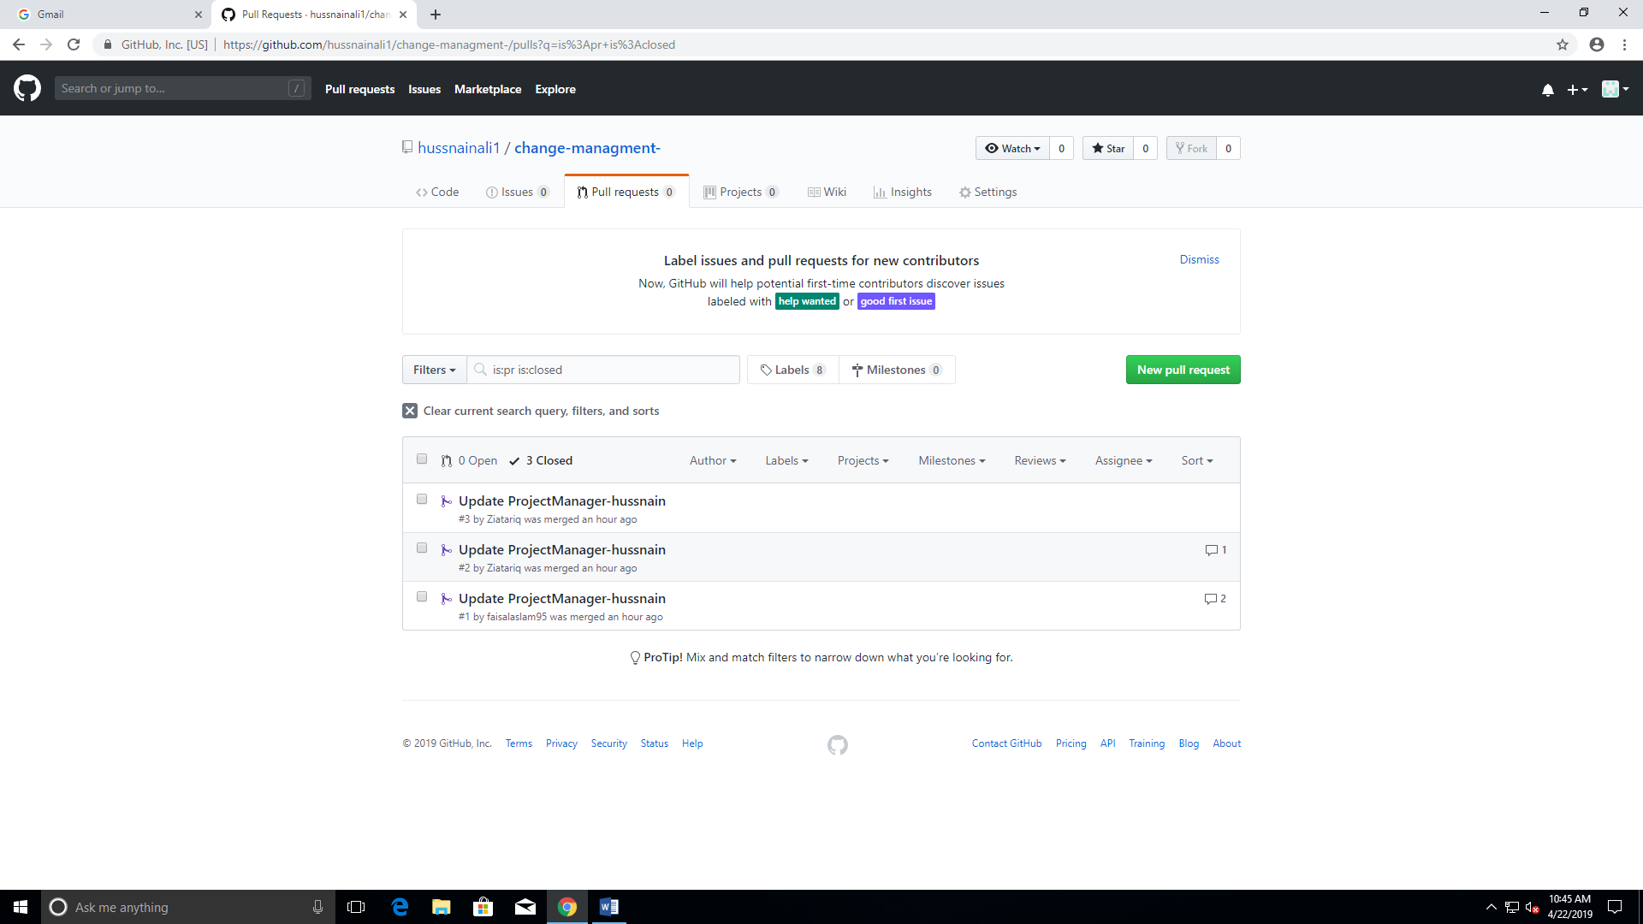

1. Then these changes has been added to the original master file which has been cloned :

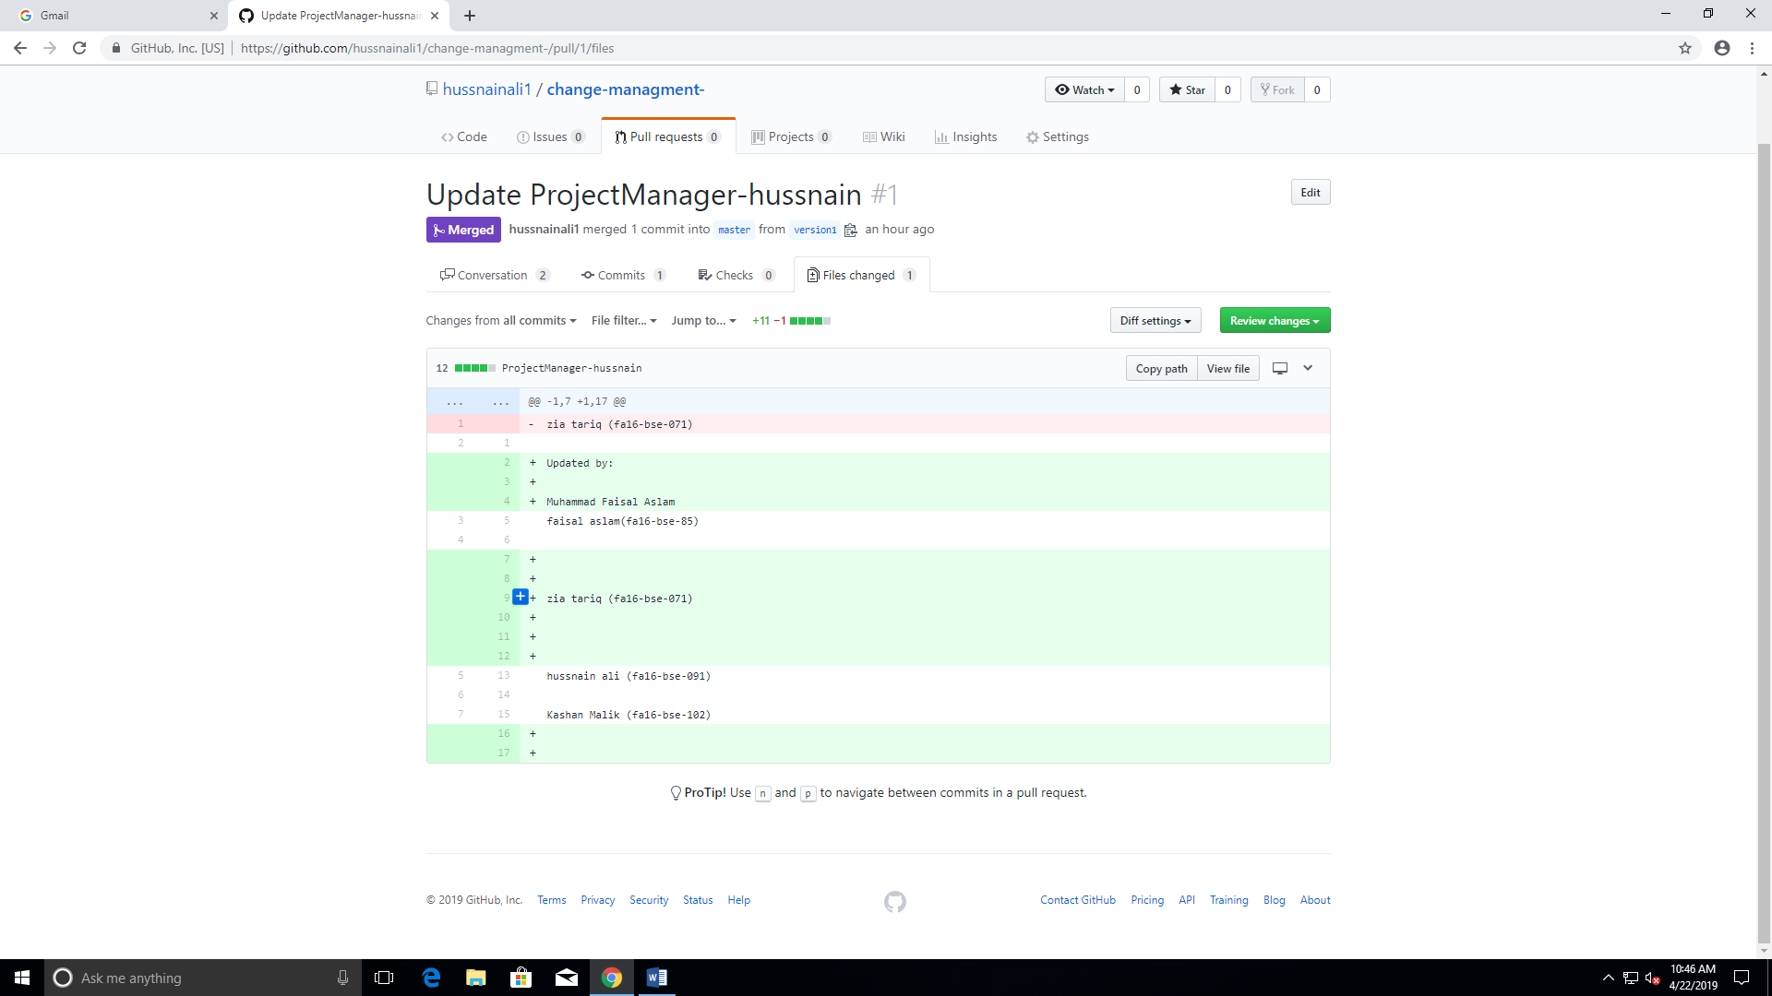

1. Then I created an issue from this panel :

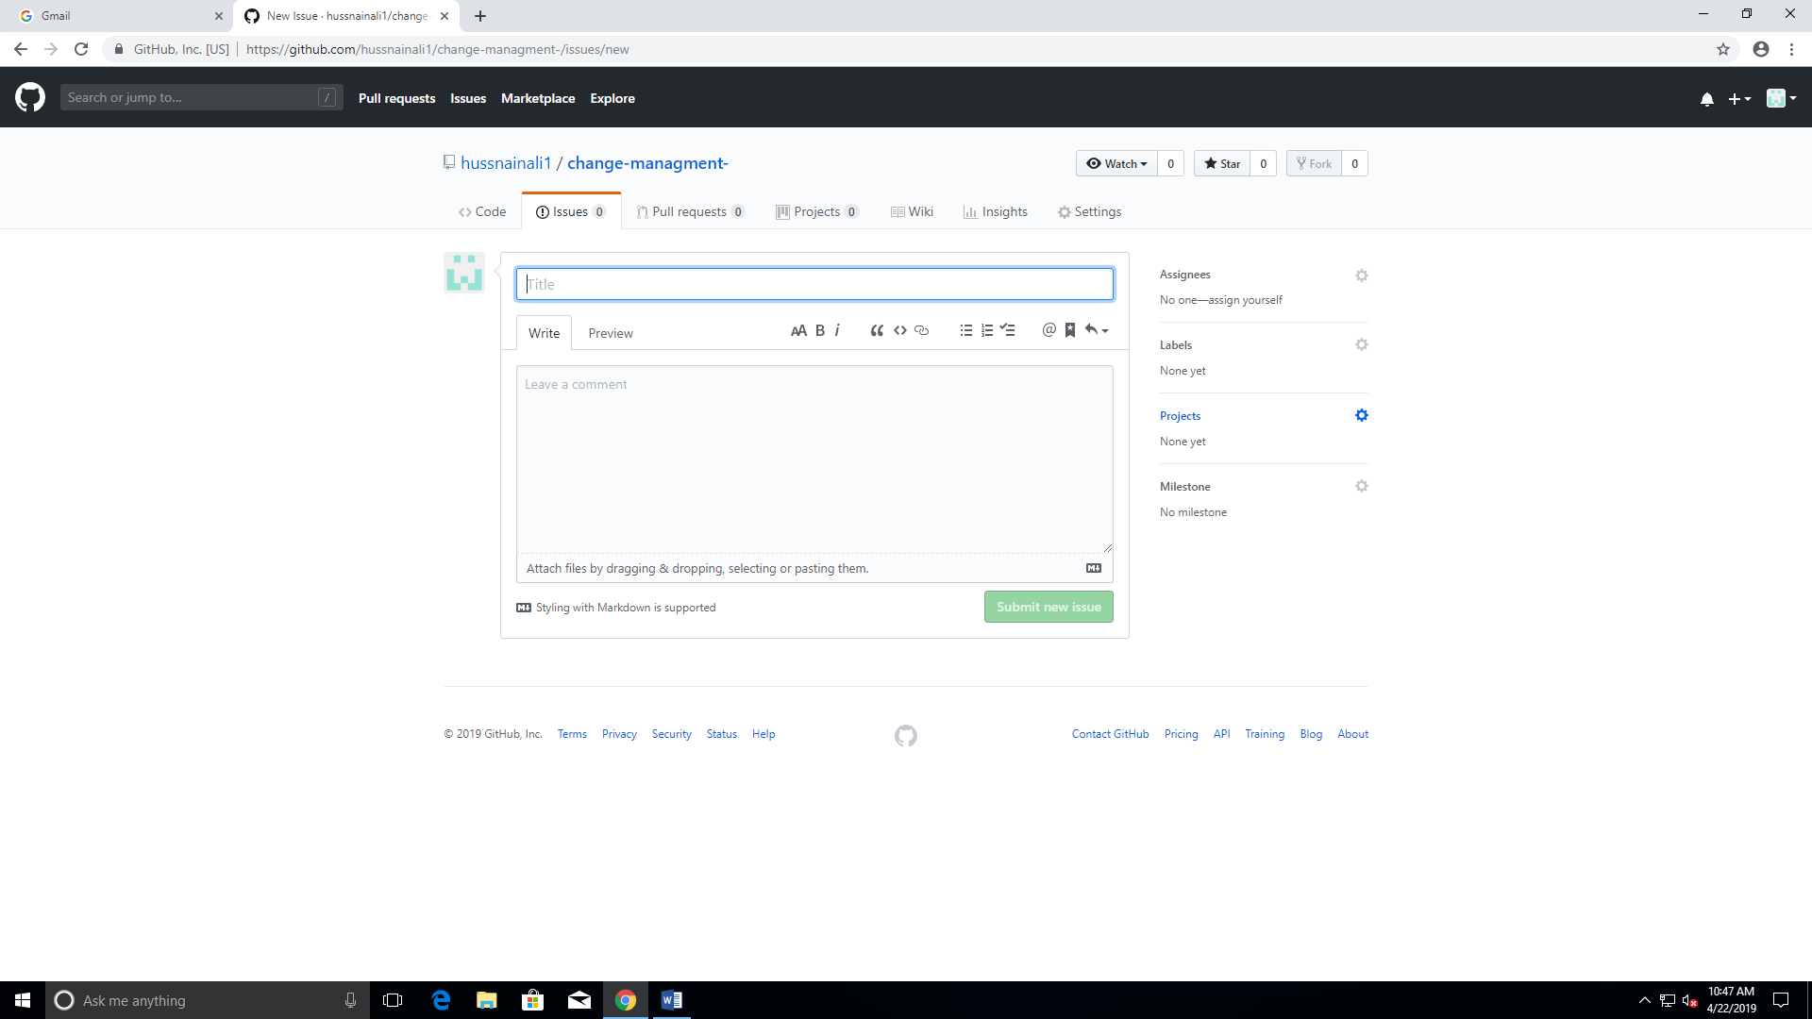

1. Then they resolve the requested issue and submit their comments and issues are resolved as shown:

